Culture and World Heritage in Greece
September 7- 16,2018
Day 1 Athens (D)
Arrival into Athens by 2pm. We will either meet at our hotel at 4pm or arrange a transfer for you at 3pm. Transfer to our hotel in central Athens. Our orientation meeting is over some Greek Coffee or tea at our rooftop bar. Next we walk a few blocks for our Welcome Dinner at a family style Greek restaurant with a view of the Acropolis.

Day 2 Athens (B,D)
We start a guided tour with a visit to the UNESCO World Heritage site, the Acropolis and a visit to the National Archeological Museum. Then you will have free time to journey through the winding charming streets and enjoy lunch on your own or buddied up. We meet back up at 3pm to visit the Agora together and learn about this special ancient market, stroll the ruins and hopeful listen to music there. Leaving we will enjoy dinner together or you can stroll back to your hotel.
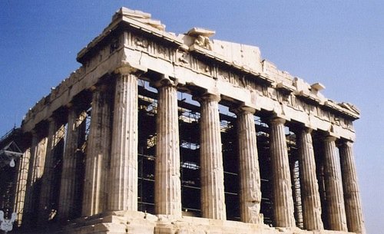

Day 3 Athens- Delphi (B,L)
Check out of our hotel. We will start this morning with a discussion about vulnerable women in the region as we are briefed by the ARIADNE Network against Trafficking in Human Beings in South-Eastern and Eastern Europe, a regional network of 16 NGOs from 12 countries. The Network was established in June 2005 with its seat in Athens, Greece. We are off to travel over land to ancient sacred site of Delphi. Once Gaea's home, later it was used as just another site for the oracle. There are as many stories about this ancient place as there are questions to ask the Oracle. We learn how the site's use evolved, from worshipping 'the mother' to punishing her daughters, the Pithies. This afternoon we will visit the Oracle, the Stadium and visit to the museum with a local historian and guide Penelope. Check in to the hotel and enjoy dinner together.
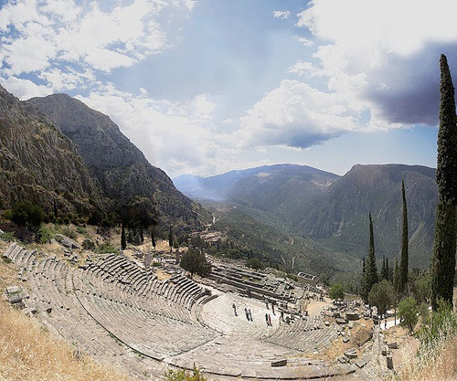

Day 4 Delphi - Lefkada Isle (B, D)
This morning we have free time to explore the town and shops of Delphi before we check out and have a quick visit the Castalia Spring, which is one of the most sanctified springs found in Delphi. It is located in the canyon of Phaedriades. The spring is still very conspicuous by its two enormous fountains that reportedly received water from the spring in ancient times. The later fountain has niches that are cut in the rocky cliff, which in all probability held the offerings to Nymph Castalia. Then we will explore’ Delphi’s Temple of Athena. Next we are off for
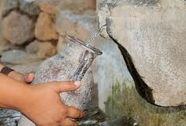
Lefkada island stop to see the stupendous structural feat of engineering,the newly built bridge of Rio Antirrio. Our Dinner tonight is at our program director's hometown, Agrinio by the biggest lake of Greece called Trichonida.

Day 5 and 6 Lefkada Island (B, L)
Over the next two days will experience local Greek life first hand. Here we will actively engage with our program officer’s family and visit their farm. We will enjoy local cuisine cooking lessons, partake in wine tasting at a local vineyard, get hands on with a soap making workshop, and enjoy swimming at local beaches. Additionally we will visit the Local Folkloric Dance Museum and yes, take a dance class if you like.
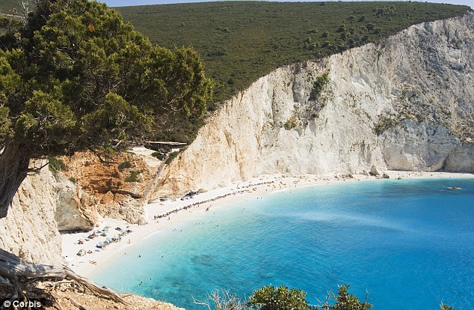

Day 7 Lefkada to Athens (B,L)
We check out of our hotel in Lefkada and return to Athens. The route this time allows us to see the Cannal of Corinth on the way back. Check into our hotel in Athens and enjoy the evening free to enjoy again the sites and markets of Athens.

Day 8 Santorini (B, L)
We check out of our hotel and leave for the Athens aiport for our flight to Santorini. Lunch is late so bring snacks for the flight. After our flight we will enjoy lunch and then visit with Agro-touristic Cooperation of Pyrgos , a medieval village for a taste of local products and wine tasting. Then we visit SantoWines, officially known as the Union of Santorini Cooperatives, was established in 1947 to protect the rights of Santorini vine growers, organize production and sales of the wine, while guaranteeing the member’s income. We check in to our hotel in Fira. After a rest we will have time to explore and shop. We will show you the path to walk up along the cliff to the two upper neighborhoods. We will have a reservation at a local restaurant were we will meet for sunset cocktails with exquisite ocean views before we go out for dinner.
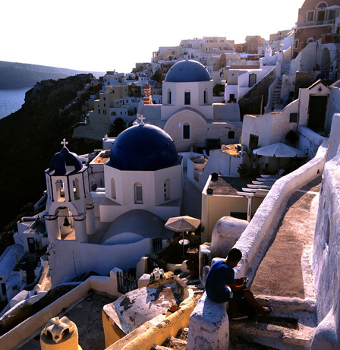

Day 9 Oia and Akrotiri (B, D)
This morning we start early to tour the important cultural sites of the world known Oia. We will have time to wander the streets, take pictures and enjoy lunch. Next we are off to explore the archaeological site of Acrotiri, one of the oldest settlement on earth. The site is a Minoan Bronze Age settlement. About 1500 BC it was buried in volcanic ash, which preserved the remains of frescoes and many objects and artworks. We return to our hotel so you have free to shop and wander. We gather at 7pm for our final Farewell Dinner.

Day 10 Santorini to Athens or USA (B)
Breakfast and check out of hotel. Then transfer to airport for late morning flight to Athens or back home. You can of course stay longer in Santorini, that is why we end in this iconic place.

This Journey is Powered by …

